Customer Event Product Document

Customer Event Product Document 2

Focus Group 2

What did Housen say? 2

Market Research 2

# Customer Event Product Document

## Focus Group

To be of quality, our product needs to appeal to our customer base as well as meet the competitive needs of the market. We must survey users to see what current products the best and what features are lacking so that our product is superior. If we can host a focus group with a diverse audience (e.g., age, gender identity, location), we will be able to create a product that not only rivals the current most popular product in the market but is better overall.

## What did Housen say?

Like the great Housen St. Claire, our founder, once said, “products are as products do.”[1] We must do what we are and are what we do.

Our company has a history of building solutions.

## Market Research

This focus group should be foundational to our product discovery knowledge. However, we cannot discount the importance of our market research. Combined they can help us tell the holistic story. We’ll be able to combine direct user stories with the broad data story.

Market research is an organized effort to gather information about target markets and customers: know about them, starting with who they are. It is an important component of business strategy and a major factor in maintaining competitiveness. Market research helps to identify and analyze the needs of the market, the market size and the competition. Its techniques encompass both qualitative techniques such as focus groups, in-depth interviews, and ethnography, as well as quantitative techniques such as customer surveys, and analysis of secondary data.

The data

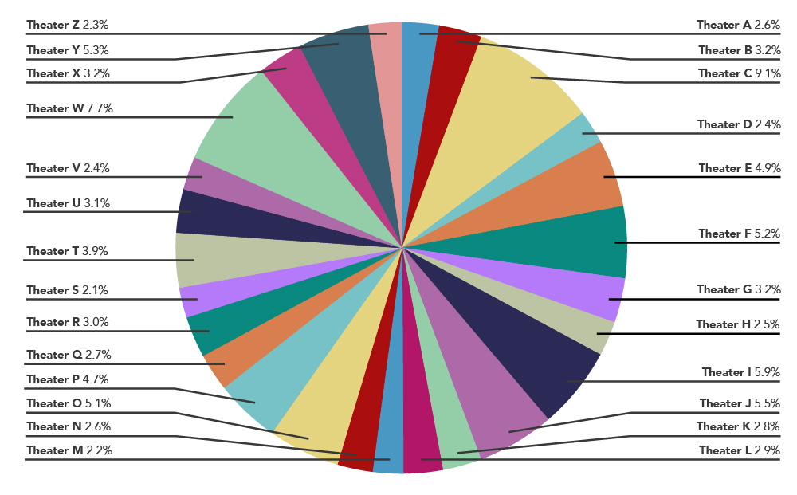

1. St. Claire, Housen. “To Be A Mogul”. Chapter 3, Page 46, line 22.